| **Test Name** | Automated Operations: Tank Level Sensor Turns Pump Off |
| --- | --- |
| **Use Case Tested:** | Automated Operations – Tank Sensor Turns Pump Off |
| **Test Description:** | Verifies that business rules/automation automatically stop the pump when high-level-threshold is reached. |
| **Pre-conditions** | * Pump is running. * Dashboard state of pump: running. * ThingsBoard has not asked the pump to stop via manual operation. * The “switch pump of when tank level is above” field is set to 2 metres. |
| **Post-conditions** | * Pump will be turned off. * An AUTOMATIC OFF message has been added to the dashboard event log. |
| **Notes:** | **This test can be run immediately after BPST003, the pre-conditions will be met.** |

|  | **TEST STEP** | **EXPECTED TEST RESULTS** |
| --- | --- | --- |
|  | Use Simulator to send tank sensor message with level of 2.0 metres. | * The tank level indicator changes to 2. This may take some time. * A downlink is scheduled with payload 00 * Dashboard state sync indicator shows yellow. |
|  | Command the pump controller to send a status message. | * Downlink Command will be received by pump controller. * Pump controller switches pump off, LED on feather goes out. * Pump controller sends a status message with pumpRunning: 0 * Dashboard Running LED will switch off. * Dashboard state sync indicator shows green. * Dashboard on/off switch is in the off state. |

|  |  |  |  |  |  |
| --- | --- | --- | --- | --- | --- |
| **Test Data Table** | | | | | |
|  | **1** | **2** | **3** | **4** | **5** |
| [Data field 1] | [data set 1 input value for field 1] |  |  |  |  |
| [Data field 2] | [data set 1 input value for field 2] |  |  |  |  |
| [Data field 3] | [data set 1 input value for field 3] |  |  |  |  |

**Results**

26/08/2020

Passed.

20:29:29.294 -> rpcRequest: v1/devices/me/rpc/request/353 - 69 - {"method":"ignored","params":{"runPump":0,"timerOn":false,"timer":0}}

20:29:29.294 -> Received op = ignored, running = 0, timerFlag = 0, timeout = 0

20:29:29.294 -> Encoded command:

20:29:29.294 -> 00

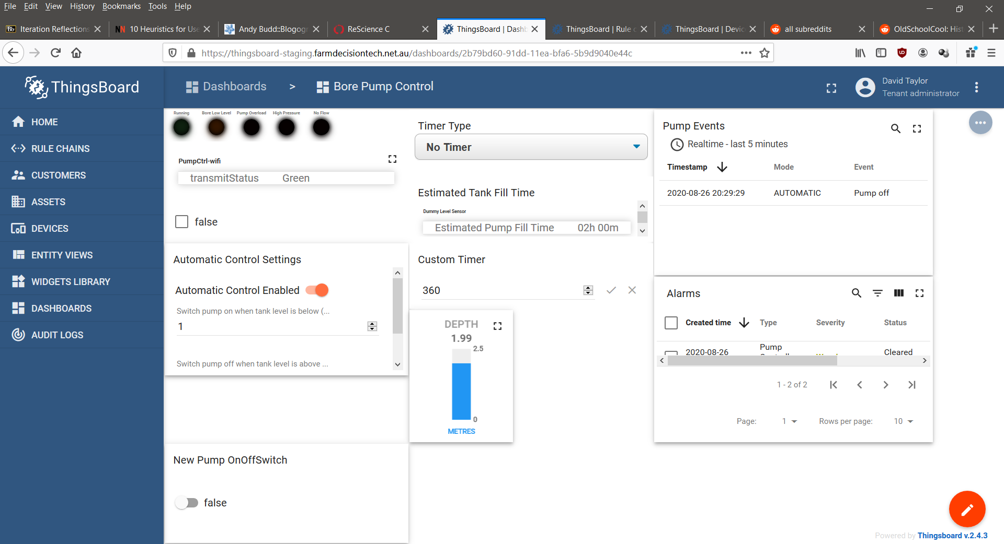

02/09/2020

Passed.

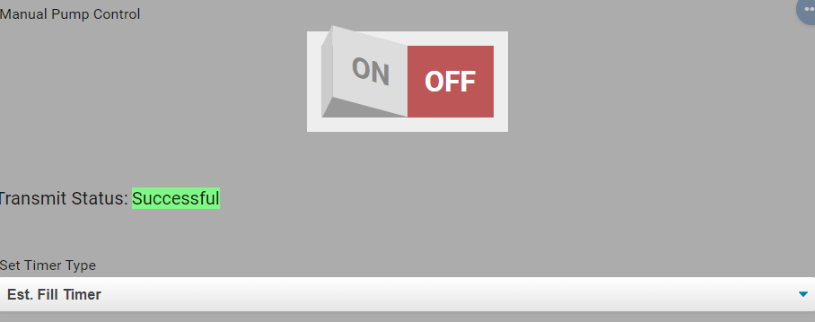

9/9/2020 – On site test at OAI.

Success.

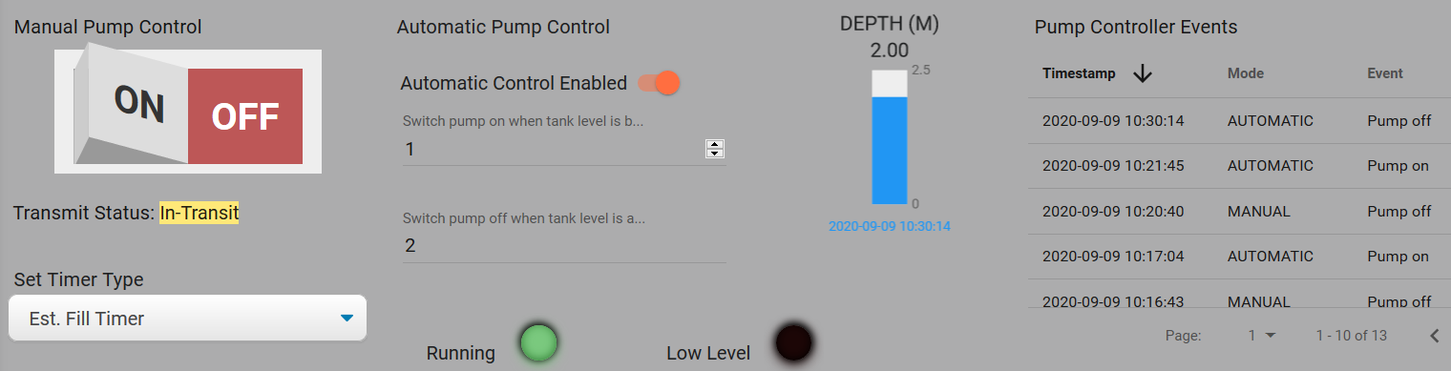

10:31:05.266 -> Send operator requested status message.

10:31:05.266 -> LoRaWAN will encode and send this message: {'pumpRunning':1,'boreLowLevel':0,'softStartFail':0,'pumpOverload':0,'controllerRestart':0,'highPressure':0,'noFlow':0}

10:31:05.266 -> Sending status byte: 01

10:31:06.374 -> EV_TXCOMPLETE (includes waiting for RX windows)

10:31:06.374 -> Received reply with 1 bytes:

10:31:06.374 -> 00

10:31:06.374 -> callback got data 0

10:31:06.374 -> Switched pump off.

10:31:06.374 -> Sending status due to state change.

10:31:06.374 -> LoRaWAN will encode and send this message: {'pumpRunning':0,'boreLowLevel':0,'softStartFail':0,'pumpOverload':0,'controllerRestart':0,'highPressure':0,'noFlow':0}

10:31:06.374 -> Sending status byte: 00

10:31:12.017 -> EV_TXCOMPLETE (includes waiting for RX windows)

